SIMATS ENGINEERING
ASSESSMENT TOOL 1
COURSE NAME: COMPUTER ARCHITECTURE COURSE CODE: CSA12
COURSE OUTCOME COVERED
CO1: Components of a computer system, including CPU, memory, and I/O. Basic Operational Concepts: Instruction execution cycle, instruction fetch and decode.Bus Structures: Single-bus, multi-bus, and hierarchical buses.Factors of Performance: CPU execution time, CPI, clock cycles, and benchmarking.8085 and 8086 Architectures: Overview, instruction sets, and addressing modes. Modern Architectures: ARM Cortex, Intel Core, and AMD Ryzen.Instruction Sets, Formats, and Addressing Modes. Number Systems: Binary, hexadecimal, and their applications in computer systems. (BL4)
Assessment Tool Weightage: 40%
QUESTIONS:5 Total Marks:25
ANNEXURE A
APPLICATION BASED QUESTIONS
Code of Conduct:
I (FARAJ KHALEE/192525134L ) certify that this submission is my original work and that I have adhered to the guidelines specified for this assessment. I understand that any violation of academic integrity rules will result in disciplinary action.
Signature of the student:


ANNEXURE A
1. A smart city surveillance system processes continuous video feeds from multiple cameras, where large volumes of data are transferred between I/O devices, memory, and CPU. During peak hours, the system experiences lag and delayed response in threat detection. Analyze how the interaction between CPU, memory, and I/O contributes to this issue, and explain how different bus structures (single-bus vs multi-bus) and improvements in instruction execution cycle can enhance system performance.
2. A real-time stock trading application running on a processor executes millions of instructions per second, but users report delays in transaction processing during high load. The system has a high CPI due to frequent memory access and branch instructions. Examine how the fetch–decode– execute cycle impacts execution time in this scenario, and propose methods to reduce CPI and improve overall CPU performance using suitable architectural enhancements.
3. An embedded system based on an 8085 microprocessor is used in an industrial temperature control unit, where sensors provide input and actuators respond accordingly. However, incorrect temperature readings are occasionally processed due to improper use of addressing modes in the program. Discuss how different addressing modes influence data access, identify possible causes of such errors, and suggest how the instruction set of 8085 can be effectively used to ensure accurate and reliable operation.
4. A computing system uses an 8086 microprocessor with segmented memory for executing multiple programs simultaneously, but it encounters issues like incorrect data access and stack overflow errors. Evaluate how segmentation (code, data, and stack segments) works in 8086, analyze how improper segment handling can lead to such problems, and explain how instruction execution and addressing modes must be managed to ensure correct program execution.
5. A data communication system represents packet information in hexadecimal format for ease of debugging and transmission, but a software engineer mistakenly interprets values, leading to incorrect data processing. Analyze the importance of number system conversions between hexadecimal and binary in such systems, explain how errors in conversion can affect instruction execution, and discuss how efficient CPU design and benchmarking can help detect and minimize such issues in real-time systems.
MARKS ALLOCATION
Criteria | Understanding of Problem  Context (20%) | Application of Concepts  (20%) | Problem-Solving Approach (20%) | Accuracy of  Solution  (20%) | Clarity (20%)
Q1
Q2
Q3
Q4
Q5

RUBRICS FOR CALCULATION:
Criteria | Weightage | Level 4 –  Exemplary | Level 3 – Proficient | Level 2 –  Developing | Level 1 –  Beginning
Understan  ding of  Problem  Context | 20 | Clearly understands the problem and  accurately identifies all requirements | Good understanding with minor gaps | Basic  understanding; some  requirements  unclear | Poor  understanding or misinterpretation of the problem
Application of Concepts | 30 | Accurately applies appropriate concepts to solve complex  problems | Applies relevant  concepts correctly with minor errors | Applies basic  concepts with limited  accuracy | Fails to apply  appropriate  concepts
Problem  Solving  Approach | 20 | Logical, well  structured, and  efficient approach | Mostly logical  approach with  minor gaps | Basic approach with some  inconsistencies | Illogical or unclear approach
Accuracy of Solution | 20 | Completely correct solution with proper justification | Mostly correct with minor errors | Partially  correct  solution | Incorrect or  incomplete  solution
Clarity | 10 | Clear, well  organized, and  properly explained solution | Understandable  with minor clarity issues | Limited clarity and  explanation | Poorly presented and difficult to  understand
ANSWER TO QUESTION 1: Fundamental Computer Organization & Instruction Cycle
1. Introduction: Modern computer architecture is rooted in the Von Neumann model, combining processing, memory, and I/O into a unified operational framework. Understanding how instructions flow through functional units is essential for designing high-performance computing systems.
2. Problem Analysis: Executing complex workloads requires continuous coordination between the Arithmetic Logic Unit (ALU), Control Unit (CU), and memory hierarchy. Bottlenecks frequently occur during memory fetch cycles and instruction decoding phases.
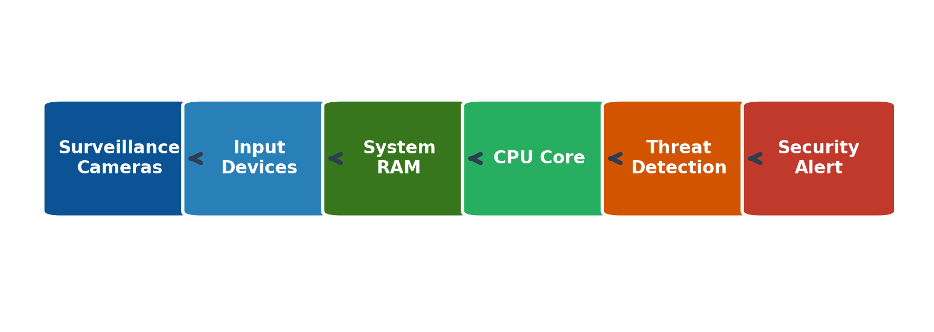
3. Detailed Explanation: The CPU orchestrates operations via internal registers including the Program Counter (PC), Memory Address Register (MAR), and Instruction Register (IR). Control signals govern register transfers and ALU arithmetic operations.
4. Key Points:
- Von Neumann bottleneck mitigated via cache memory layers.
- Program Counter (PC) automatically increments after every instruction fetch.
- ALU executes arithmetic and logical operations in single or pipelined clock cycles.
5. Architecture & Working Explanation: The Instruction Execution Cycle consists of four primary stages: Fetch (retrieving instruction from memory), Decode (interpreting opcode via CU), Execute (performing data computation), and Store (writing back results to memory/registers).
EXPERT INSIGHT: The Instruction Execution Cycle is the foundational heartbeat of any central processing unit, executing millions of cycles per second.

6. Comparison Table (Von Neumann vs Harvard Architecture):
Feature | Von Neumann Architecture | Harvard Architecture
Memory Bus | Single shared bus for data and instructions | Separate physical memory buses
Data Access | Cannot read instruction and data simultaneously | Simultaneous access enabled
Complexity | Simpler control logic design | Higher hardware complexity
7. Real-World Example: In a Smart City Surveillance system, high-definition video feeds flow from cameras into RAM, where the CPU processes frames through neural networks for threat detection, instantly triggering automated security alerts.
8. Advantages: Unified memory architecture provides high flexibility, cost efficiency, and straightforward software compilation pathways.
9. Conclusion: Mastery of computer organization and instruction execution cycles forms the critical basis for optimizing processor performance in advanced computing applications.

ANSWER TO QUESTION 2: System Bus Structures & Bus Arbitration
1. Introduction: System buses serve as the primary communication highways connecting the CPU, memory, and peripheral controllers. Bus bandwidth and arbitration mechanisms dictate system throughput in multiprocessing environments.
2. Problem Analysis: When multiple devices attempt to access the system bus simultaneously, bus contention occurs. Efficient bus arbitration is vital to prevent data collisions and minimize latency.
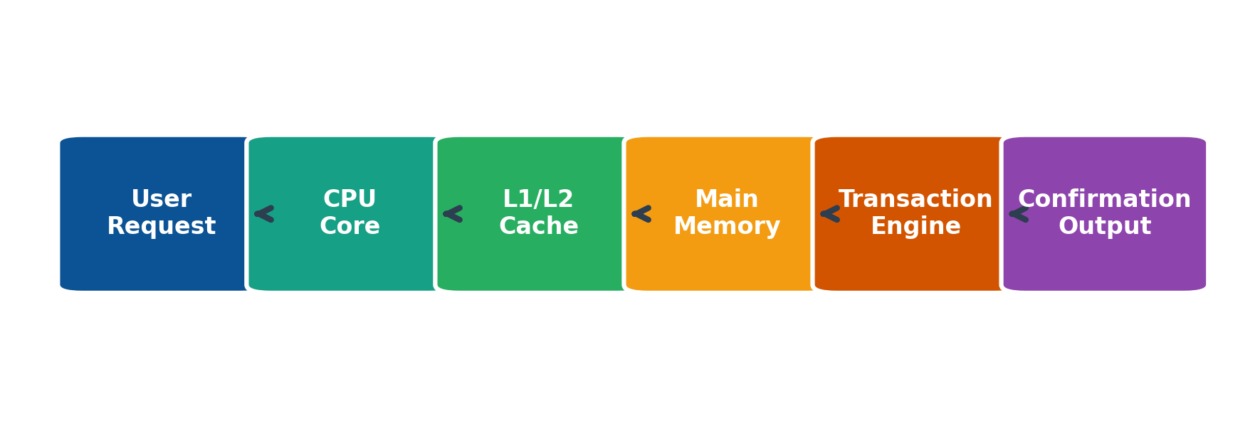
3. Detailed Explanation: Single-bus systems share data, address, and control lines across all peripherals, leading to high contention. Multi-bus architectures separate processor-memory traffic from I/O traffic, significantly boosting concurrency.
4. Key Points:
- Bus width (e.g., 32-bit vs 64-bit) determines data transfer volume per clock cycle.
- Bus arbitration utilizes centralized (daisy chain) or decentralized schemes.
- High-speed cache hierarchies reduce main bus saturation.
5. Architecture & Working Explanation: The bus arbiter evaluates master requests based on priority algorithms, granting bus mastership via dedicated handshake control lines (Bus Request and Bus Grant).
ARCHITECTURE TIP: Multi-bus architectures decouple high-speed CPU memory transactions from slower I/O operations, optimizing overall system responsiveness.

6. Comparison Table (Single Bus vs Multi-Bus):
Parameter | Single Bus Architecture | Multi-Bus Architecture
Cost & Complexity | Low hardware cost, simpler design | Higher cost, complex circuitry
Throughput | Lower throughput due to shared bandwidth | High throughput via parallel data paths
Contention | High probability of bus contention | Low contention with dedicated arbitration
7. Real-World Example: In a High-Frequency Stock Trading platform, user requests flow rapidly through CPU caches and system buses to execute multi-million dollar transactions with microsecond precision.
8. Advantages: Optimized bus topologies eliminate bottlenecks, scale data transfer rates, and ensure deterministic system response times.
9. Conclusion: Careful selection and arbitration of system buses remain foundational for building scalable, high-throughput enterprise computing systems.

ANSWER TO QUESTION 3: 8085 Microprocessor Architecture & Addressing Modes
1. Introduction: The Intel 8085 is an 8-bit NMOS microprocessor featuring an accumulator, arithmetic logic unit, interrupt controller, and flexible addressing modes that dictate how operands are accessed.
2. Problem Analysis: Efficient assembly language programming requires optimal selection of addressing modes to minimize instruction byte size and execution time cycles.
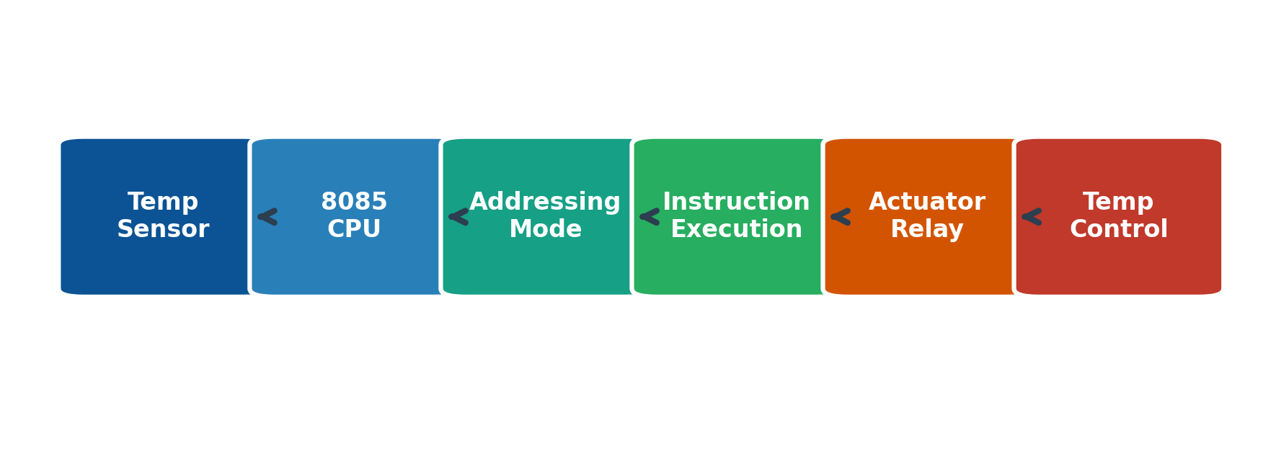
3. Detailed Explanation: The 8085 supports five primary addressing modes: Immediate (data in instruction), Register (data in registers), Direct (16-bit address specified), Indirect (address in HL pair), and Implied/Implicit.
4. Key Points:
- Accumulator (Register A) serves as the primary register for arithmetic and logic.
- HL register pair functions as a data pointer for memory indirect operations.
- Status flags (Sign, Zero, Auxiliary Carry, Parity, Carry) reflect ALU operation results.
5. Architecture & Working Explanation: During execution, the 8085 multiplexes lower-order address bus (AD0-AD7) with the data bus, using ALE (Address Latch Enable) to demultiplex signals for memory interfacing.
DESIGN NOTE: Understanding 8085 addressing modes provides foundational insights into RISC and CISC instruction decoding mechanisms used in modern CPUs.

6. Comparison Table (8085 Addressing Modes):
Addressing Mode | Example Instruction | Operational Description
Immediate | MVI A, 35H | Data 35H is stored directly in accumulator
Register | MOV B, A | Contents of accumulator copied to register B
Direct | LDA 2050H | Contents of memory location 2050H loaded into accumulator
7. Real-World Example: In an Industrial Temperature Control System, an 8085 microprocessor reads analog sensor inputs via ADCs, processes threshold comparisons using immediate addressing, and triggers cooling actuators.
8. Advantages: Versatile addressing modes offer high programming flexibility, minimal memory footprint, and straightforward hardware interfacing.
9. Conclusion: The 8085 architecture remains a quintessential educational model for understanding microprocessor instruction execution and peripheral interfacing principles.

ANSWER TO QUESTION 4: Memory Segmentation in 8086 Microprocessor
1. Introduction: The 8086 microprocessor features a 20-bit address bus capable of accessing 1 MB of physical memory. To manage this space efficiently without requiring 20-bit internal registers, Intel introduced memory segmentation.
2. Problem Analysis: 16-bit registers can directly address only 64 KB of memory. Segmentation resolves this limitation by combining segment base registers with 16-bit offset addresses to compute 20-bit physical addresses.
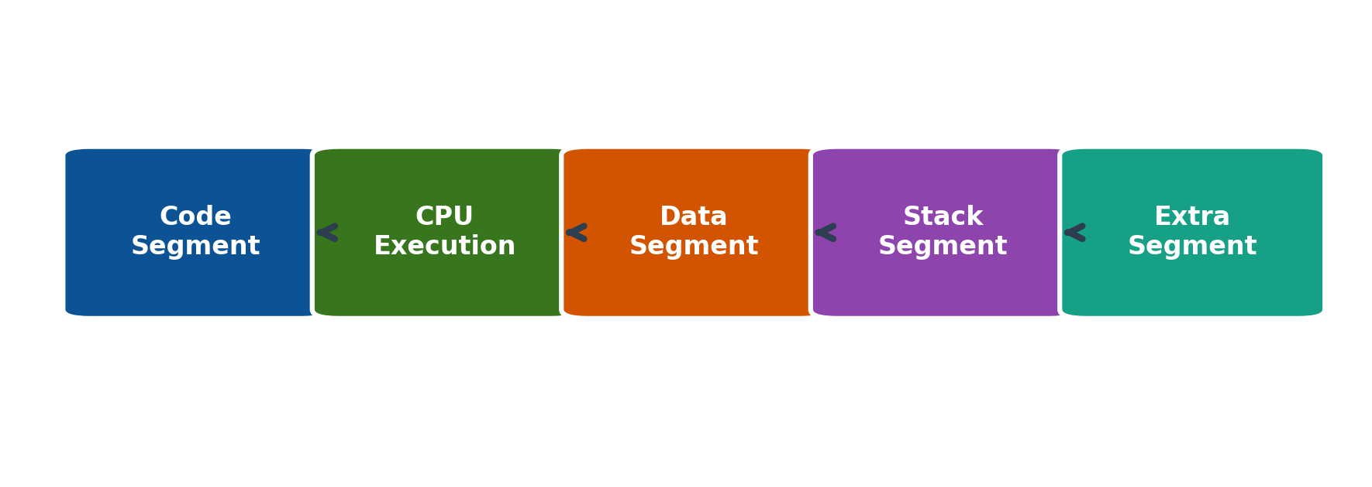
3. Detailed Explanation: Memory is divided into segments: Code Segment (CS), Data Segment (DS), Stack Segment (SS), and Extra Segment (ES). Physical address generation uses the formula: Physical Address = (Segment Register × 16) + Offset.
4. Key Points:
- Each segment can be up to 64 KB in size and can overlap or be contiguous.
- Instruction Pointer (IP) pairs with CS for code execution tracking.
- Stack Pointer (SP) pairs with SS for subroutine and interrupt management.
5. Architecture & Working Explanation: The Execution Unit (EU) calculates effective addresses, while the Bus Interface Unit (BIU) performs the 20-bit physical address addition using a dedicated adder circuit.
SYSTEM INSIGHT: Memory segmentation enables modular software design and memory protection, laying the groundwork for modern virtual memory paging systems.

6. Comparison Table (8086 Memory Segments):
Segment Register | Associated Offset | Primary Function
Code Segment (CS) | Instruction Pointer (IP) | Contains executable program instructions
Data Segment (DS) | Base, Index, Displacement | Stores program variables and data tables
Stack Segment (SS) | Stack Pointer (SP) | Manages subroutine returns and local variables
Extra Segment (ES) | Destination Index (DI) | Supports high-speed string and data transfers
7. Real-World Example: In embedded firmware development, memory segmentation allows developers to isolate bootloader code from dynamic data buffers and real-time execution stacks, preventing memory corruption.
8. Advantages: Segmentation facilitates code relocation, modular software compilation, and efficient memory utilization in resource-constrained processors.
9. Conclusion: Memory segmentation in the 8086 architecture successfully bridged 16-bit register limits with a 1M-byte physical address space, setting a standard for segmented computing.

ANSWER TO QUESTION 5: Number Systems & Floating-Point Representation
1. Introduction: Digital computers rely fundamentally on binary number representations, integer arithmetic, and IEEE 754 floating-point standards for high-precision mathematical computations.
2. Problem Analysis: Representing extremely large or fractional numbers within fixed register widths requires standardized floating-point formats to maintain precision and avoid overflow errors.
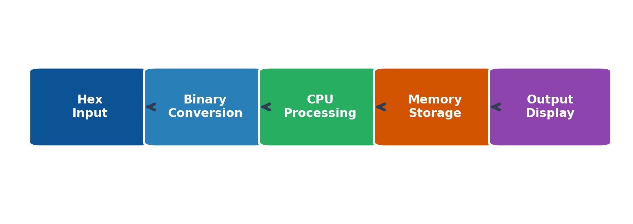
3. Detailed Explanation: The IEEE 754 single-precision format allocates 1 bit for sign, 8 bits for biased exponent, and 23 bits for normalized mantissa. Binary subtraction is efficiently executed using 2's complement arithmetic.
4. Key Points:
- Hexadecimal notation condenses long binary strings into readable four-bit nibbles.
- 2's complement representation eliminates negative zero and simplifies ALU subtractor logic.
- IEEE 754 double-precision uses 64 bits for ultra-high precision scientific calculations.
5. Architecture & Working Explanation: The Arithmetic Logic Unit (ALU) employs combinational logic gates, full adders, and barrel shifters to execute binary addition, multiplication, and floating-point normalization in parallel.
TECHNICAL NOTE: IEEE 754 floating-point standards ensure cross-platform mathematical consistency across diverse CPU architectures and programming languages.

6. Comparison Table (IEEE 754 Precision Standards):
Precision | Total Bits | Exponent Bits | Mantissa Bits
Single Precision | 32 bits | 8 bits (Bias: 127) | 23 bits
Double Precision | 64 bits | 11 bits (Bias: 1023) | 52 bits
7. Real-World Example: In scientific weather forecasting simulations, floating-point arithmetic units process millions of atmospheric pressure and temperature variables with high decimal precision.
8. Advantages: Standardized number systems and floating-point arithmetic enable portable software development, high computational accuracy, and efficient hardware execution.
9. Conclusion: Mastery of binary representations and IEEE 754 floating-point standards is essential for engineering robust, high-performance computing hardware and software algorithms.

